Batch: C3 Roll No.: 16010123217

Experiment No. 05

Grade: AA / AB / BB / BC / CC / CD /DD

Signature of the Staff In-charge with date

TITLE: Implementation of Basic Process management algorithms - Preemptive (SRTN, RR)
_____________________________________________________________________
AIM: To implement basic Process management algorithms ( Round Robin, SRTN
_____________________________________________________________________
Expected Outcome of Experiment:
CO 2. To understand the concept of process, thread and resource management. _____________________________________________________________________
Books/ Journals/ Websites referred:

- Silberschatz A., Galvin P., Gagne G. “Operating Systems Principles”, Willey Eight edition.
- Achyut S. Godbole , Atul Kahate “Operating Systems” McGraw Hill Third
- Edition.
- William Stallings, “Operating System Internal & Design Principles”, Pearson.
- Andrew S. Tanenbaum, “Modern Operating System”, Prentice Hall.
_____________________________________________________________________
Pre Lab/ Prior Concepts:
Most systems handle numerous processes with short CPU bursts interspersed with I/O requests and a few processes with long CPU bursts. To ensure good time-sharing performance, a running process may be preempted to allow another to run. The ready list, or run queue, maintains all processes ready to run and not blocked by I/O or other system requests. Entries in this list point to the process control block, which stores all process information and state.
When an I/O request completes, the process moves from the waiting state to the ready state and is placed on the run queue. The process scheduler, a key component of the operating system, decides whether the current process should continue running or if another should take over. This decision is triggered by four events:
- The current process issues an I/O request or system request, moving it from running to waiting.
- The current process terminates.
- A timer interrupt indicates the process has run for its allotted time, moving it from running to ready.
- An I/O operation completes, moving the process from waiting to ready, potentially preempting the current process.
The scheduling algorithm, or policy, determines the sequence and duration of process execution, a complex task given the limited information about ready processes.
_____________________________________________________________________
Description of the application to be implemented:
Round Robin Algorithm
• Input: Number of processes, their arrival time and burst time, and the time quantum.
• Initialize:
- Set remaining_time[i] = burst_time[i] for all processes.
- Set current_time = 0.
- Use a queue to keep track of processes.
• Process Execution:
- Add all processes that have arrived to the queue.
- While there are processes in the queue:
  - Pick the first process from the queue.
  - Execute it for min(time quantum, remaining_time).
  - Update current_time += executed_time.
  - If the process is not finished:
    - Reinsert it at the end of the queue.
  - Else:
    - Calculate Completion Time = current_time
    - Calculate **Turnaround Time (TAT) = Completion Time - Arrival Time`
    - Calculate **Waiting Time (WT) = TAT - Burst Time`
• Compute:
- Average Turnaround Time = Sum of TATs / Number of Processes
- Average Waiting Time = Sum of WTs / Number of Processes
• Output: Display the scheduling order, completion time, TAT, and WT.

Shortest Remaining Time First Algorithm:
• Input: Number of processes, their arrival time and burst time.
• Initialize:
- Set remaining_time[i] = burst_time[i] for all processes.
- Set current_time = 0 and completed = 0.
• Process Execution:
- While all processes are not completed (completed < n):
  - Find the process with the shortest remaining time among those that have arrived (arrival_time[i] <= current_time).
  - If no process is available, increment current_time.
  - Else:
    - Execute the selected process for 1 time unit.
    - Decrease its remaining_time by 1.
    - If remaining_time == 0:
      - Mark the process as completed.
      - Compute Completion Time = current_time + 1.
      - Compute TAT = Completion Time - Arrival Time.
      - Compute WT = TAT - Burst Time.
      - Increment completed.
  - Repeat until all processes finish.
• Compute:
- Average Turnaround Time = Sum of TATs / Number of Processes
- Average Waiting Time = Sum of WTs / Number of Processes
• Output: Display the completion time, TAT, and WT.
Implementation details: (printout of code)
Round Robin:-
#include <bits/stdc++.h>
using namespace std;

struct Process {
int pid, arrival, burst, remaining, completion, turnaround, waiting;
};

void roundRobin(vector<Process>& processes, int quantum) {
int time = 0, n = processes.size();
queue<int> q;
vector<bool> inQueue(n, false);
float avgTAT = 0, avgWT = 0;

for (auto& p : processes) p.remaining = p.burst;

q.push(0);
inQueue[0] = true;

while (!q.empty()) {
int i = q.front();
q.pop();

int execute_time = min(quantum, processes[i].remaining);
time += execute_time;
processes[i].remaining -= execute_time;

for (int j = 0; j < n; j++) {
if (!inQueue[j] && processes[j].arrival <= time && processes[j].remaining > 0) {
q.push(j);
inQueue[j] = true;
}
}

if (processes[i].remaining > 0) {
q.push(i);
} else {
processes[i].completion = time;
processes[i].turnaround = processes[i].completion - processes[i].arrival;
processes[i].waiting = processes[i].turnaround - processes[i].burst;
avgTAT += processes[i].turnaround;
avgWT += processes[i].waiting;
}
}

avgTAT /= n;
avgWT /= n;

cout << "\nRound Robin Scheduling (Quantum = " << quantum << ")\n";
cout << "PID\tArrival\tBurst\tCompletion\tTurnaround\tWaiting\n";
for (auto& p : processes) {
cout << p.pid << "\t" << p.arrival << "\t" << p.burst << "\t" << p.completion
<< "\t\t" << p.turnaround << "\t\t" << p.waiting << "\n";
}
cout << "Average Turnaround Time: " << avgTAT << "\n";
cout << "Average Waiting Time: " << avgWT << "\n";
}

int main() {
int n, quantum;
cout << "Enter number of processes: ";
cin >> n;

vector<Process> processes(n);
cout << "Enter Process ID, Arrival Time, and Burst Time:\n";
for (int i = 0; i < n; i++) {
cin >> processes[i].pid >> processes[i].arrival >> processes[i].burst;
}

cout << "Enter time quantum: ";
cin >> quantum;

sort(processes.begin(), processes.end(), [](Process a, Process b) {
return a.arrival < b.arrival;
});

roundRobin(processes, quantum);
}

Output: -
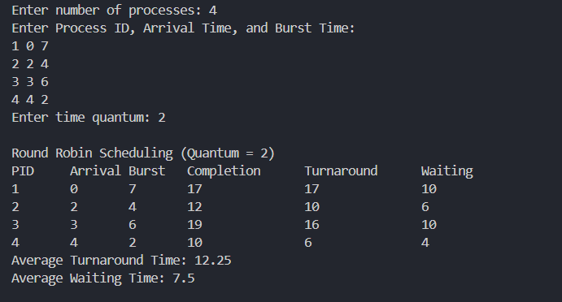
SRTF: -
#include <bits/stdc++.h>
using namespace std;

struct Process {
int pid, arrival, burst, remaining, completion, turnaround, waiting;
};

void srtn(vector<Process>& processes) {
int time = 0, completed = 0, n = processes.size();
float avgTAT = 0, avgWT = 0;

for (auto& p : processes) p.remaining = p.burst;

while (completed < n) {
int min_index = -1, min_remaining = INT_MAX;

for (int i = 0; i < n; i++) {
if (processes[i].arrival <= time && processes[i].remaining > 0 &&
processes[i].remaining < min_remaining) {
min_remaining = processes[i].remaining;
min_index = i;
}
}

if (min_index != -1) {
processes[min_index].remaining -= 1;
time++;

if (processes[min_index].remaining == 0) {
completed++;
processes[min_index].completion = time;
processes[min_index].turnaround =
processes[min_index].completion - processes[min_index].arrival;
processes[min_index].waiting =
processes[min_index].turnaround - processes[min_index].burst;
avgTAT += processes[min_index].turnaround;
avgWT += processes[min_index].waiting;
}
} else {
time++;
}
}

avgTAT /= n;
avgWT /= n;

cout << "\nShortest Remaining Time Next (SRTN) Scheduling\n";
cout << "PID\tArrival\tBurst\tCompletion\tTurnaround\tWaiting\n";
for (auto& p : processes) {
cout << p.pid << "\t" << p.arrival << "\t" << p.burst << "\t" << p.completion
<< "\t\t" << p.turnaround << "\t\t" << p.waiting << "\n";
}
cout << "Average Turnaround Time: " << avgTAT << "\n";
cout << "Average Waiting Time: " << avgWT << "\n";
}

int main() {
int n;
cout << "Enter number of processes: ";
cin >> n;

vector<Process> processes(n);
cout << "Enter Process ID, Arrival Time, and Burst Time:\n";
for (int i = 0; i < n; i++) {
cin >> processes[i].pid >> processes[i].arrival >> processes[i].burst;
}

sort(processes.begin(), processes.end(), [](Process a, Process b) {
return a.arrival < b.arrival;
});

srtn(processes);
}

Output: -
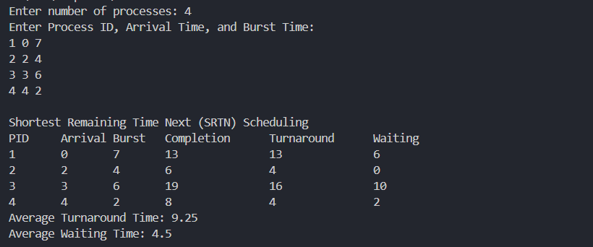
Conclusion:
In this experiment, we implement the Round Robin and Shortest Remaining Time First (SRTF) CPU scheduling algorithms, which fall under preemptive scheduling. These algorithms help reduce the average waiting time by either prioritizing the shortest process first or ensuring that all processes get an equal share of CPU time.
Post Lab Descriptive Questions

- Consider three processes, all arriving at time zero, with total execution time of 10, 20 and 30 units, respectively. Each process spends the first 20% of execution time doing I/O, the next 70% of time doing computation, and the last 10% of time doing I/O again. The operating system uses a shortest remaining compute time first scheduling algorithm and schedules a new process either when the running process gets blocked on I/O or when the running process finishes its compute burst. Assume that all I/O operations can be overlapped as much as possible. For what percentage of time does the CPU remain idle?

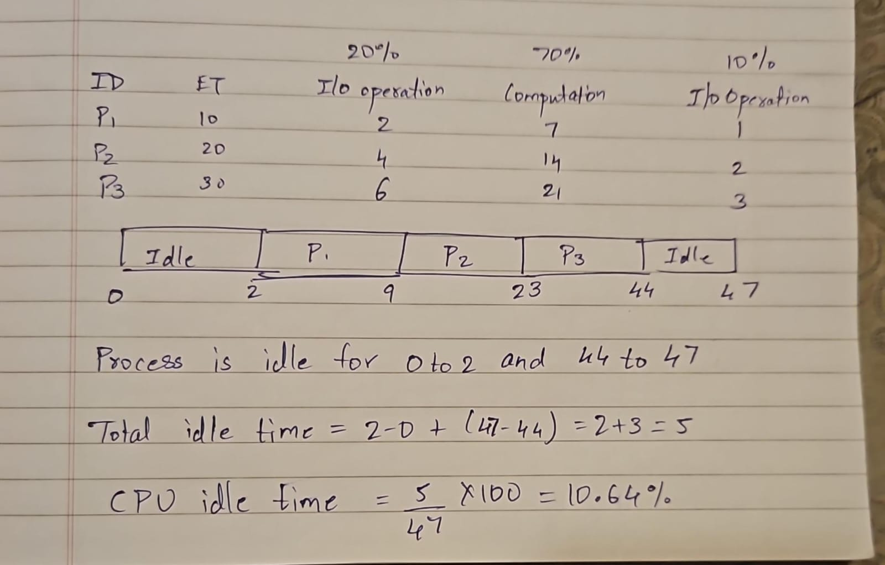
- What effect the time quantum has on its performance. What are the advantages and disadvantages of using a small versus a large time quantum?

Ans:-
The time quantum in Round Robin scheduling directly impacts CPU utilization, throughput, response time, and context switching overhead. Choosing the right quantum is essential for balancing efficiency and fairness.

Small Time Quantum
A small time quantum means the CPU frequently switches between processes.

Advantages:
- Better Responsiveness: Shorter tasks complete quickly, reducing wait times.
- Fair CPU Allocation: All processes get frequent CPU access, preventing starvation.
- Improved Interactivity: Suitable for interactive systems where user input needs fast responses.

Disadvantages:
- High Context Switching Overhead: More CPU time is spent switching tasks rather than executing them.
- Lower Throughput: More frequent switches slow down overall execution.
- Poor Cache Performance: Frequent context switches disrupt CPU cache, reducing efficiency.

Large Time Quantum
A large time quantum allows processes to run longer before switching.

Advantages:
- Lower Context Switching Overhead: Less frequent switching improves CPU efficiency.
- Higher Throughput: More processes complete within a given time.
- Better CPU Utilization: The CPU spends more time executing tasks instead of managing switches.

Disadvantages:
- Poor Responsiveness: Short tasks may experience long wait times.
- Reduced Fairness: Long-running processes dominate CPU time.
- Potential Starvation: If too large, Round Robin behaves like First-Come First-Served (FCFS), delaying shorter tasks.

- The following processes are scheduled using the Robin process scheduling policy with a time quantum of 3ms. Determine the average waiting time.
Process | Arrival Time | Burst Time
P1 | 0 | 6
P2 | 1 | 2
P3 | 3 | 8
P4 | 5 | 3
P5 | 2 | 4

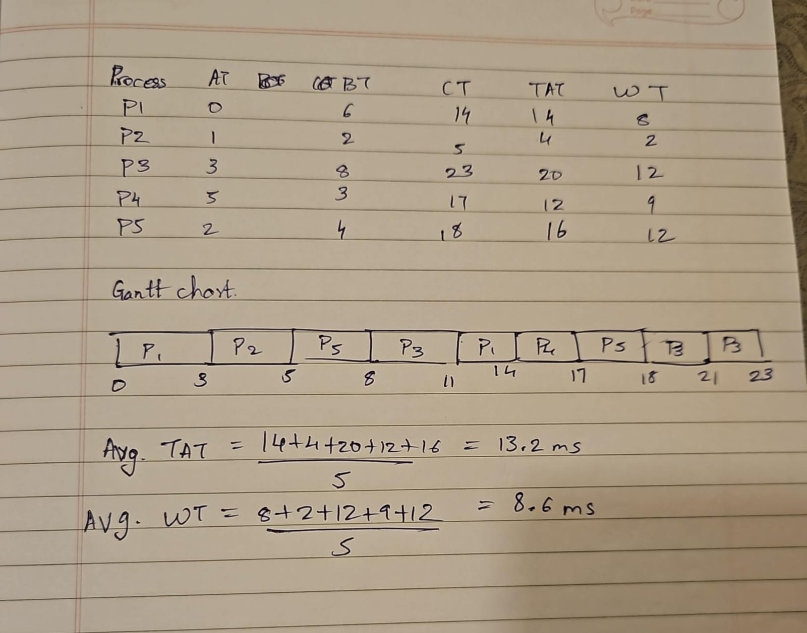
Date: 20/03/25 Signature of faculty in-charge

